# Worksheet 2 Processor performance

**Task 1 Word length**

1. Memory is divided into equal units called **words**. Each word has a separate memory address.

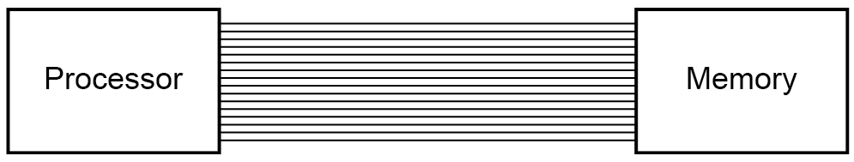

A processor uses a word length of 16 bits and has an address bus of 16 lines.

1. What is the maximum number of addressable words in memory?

2^16

1. What is the overall memory capacity in KiB?

2^16*2 = 131072

131072/1024=128 KiB

1. How does the width of the address bus affect system performance?

The thicker your address bus, the more maximum possible memory addresses the system can have

1. How does the width of the data bus affect system performance?

If the data bus is the same width as the word length in the computer then data can be transferred to and from memory in a single operation

2. (a) Fill in the blanks from the words or phrases given below.

In computing , **word** is a term for the natural unit of data used by computer architecture design. A word is a fixed-sized piece of data handled as a unit by the processor or the hardware of the processor. The number of bits in a word (the word length) is an important characteristic of any specific processor design or instruction set.

**bits computer architecture computing instruction set piece of data processor word length**

(b) Complete the table to say whether each of the following statements is true or false.

|  |  |
| --- | --- |
|  | **True or False** |
| One assembly language instructions is generally translated into several machine code instructions | False |
| The word length of the processor and the width of the address bus are factors in the format of a machine code instruction | True |
| Different types of computers have different architectures and therefore different machine code instruction sets | True |
| A processor with a 16-bit address bus cannot address more than 65,536 memory locations | True |

**Task 2 – Testing system performance**

3. Daniel tests the performance of his computer on the website <https://novabench.com/>

He obtains the following results:

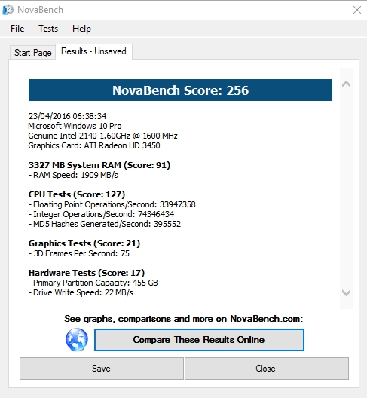

He then compares them against average scores form other users:

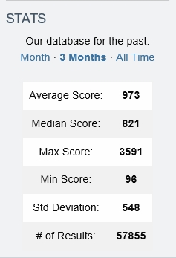

Suggest possible reasons why his computer is performing poorly against the average. Is there anything he could do to improve performance?

His PC is terrible, get a new PC

4. Try benchmarking your own computer using the free downloadable software from the website.